**FERTILIZERS RECOMMENDATION SYSTEM FOR DISEASE PREDICTION**

**ABSTRACT**

Agriculture is the maximum vital region in today’s life. Most flowers are suffering from a huge type of bacterial and fungal sicknesses. Diseases on flowers located a prime constraint on the manufacturing and a prime hazard to meals security. Hence, early and correct identity of plant sicknesses is crucial to make certain excessive amount and first-class quality. In latest years, the number of sicknesses on flowers and the diploma of damage precipitated has expanded because of the variant in pathogen varieties, modifications in cultivation methods, and insufficient plant safety strategies. An computerized gadget is added to pick out special sicknesses on flowers via way of means of checking the signs and symptoms proven at the leaves of the plant. Deep gaining knowledge of strategies are used to pick out the sicknesses and recommend the precautions that may be taken for the ones sicknesses.

**INTRODUCTION**

Machine learning is particularly effective in detecting and recognising plant illnesses, and it can provide early disease signs identification. Plant disease specialists can examine the digital photos processed with digital image processing to identify blights on plants. computer vision and image processing applications Processing methods merely help farmers throughout all regions. about agriculture. In most cases, plant diseases are brought on by plant physiological functions that are aberrant. as a result, the generation of distinctive symptoms is based on the distinguishing between typical physiological functions and abnormalities in the way that plants function physiologically. Typically, the pathogens that cause plant leaf diseases are put in place on the plants' stems.

These are distinct Different factors can predict the signs and diseases of leaves processing methods for images. These many approaches make use of various core techniques like segmentation, feature extraction, and classification, among others. Most often, segmentation is used to distinguish between healthy and diseased tissues of leaves in order to forecast and diagnose leaf diseases.

**PROBLEM STATEMENT**

The most important problem in agriculture is that the disease that affects the plants, trees and crops. The disease can be found easily in the early stage by looking at changes of colour of the leaves. So, without knowing about the correct disease they use some fertilizers and it doesn’t cure the disease properly. This fertilizer recommendation system helps to find the accurate disease and helps them to cure the disease and increase in the growth of plants.

**LITRATURE SURVEY**

**1.Fertilizers Recommendation System For Disease Prediction In Tree Leave**

**Authors:** R. Neela, P. Nithya

A digital camera or similar devices are used to take images of different types, and then those are used to identify the affected area in leaves. Then different types of image-processing techniques are applied to them, the process those images, to get different and useful features needed for the purpose of analyzing later-Plant leaf disease identification is especially needed to predict both the quality and quantity of the First segmentation step primarily based on a mild polygonal leaf model is first achieved and later used to guide the evolution of an energetic contour. Combining global shape descriptors given by the polygonal model with local curvaturebased features, the leaves are then classified overleaf datasets. In this research work introduce a method designed to deal with the obstacles raised by such complex images, for simple and plant leaves. A first segmentation step based on graph-cut approach is first performed and later used to guide the evolution of leaf boundaries, and implement classification algorithm to classify the diseases and recommend the fertilizers to affected leaves

**2.Fertilizer recommendation for Agriculture International Journal of Business, Management and Social Research**

**Authors:** Jakia Sultana, M. N. A. Siddique, Md. Rishad Abdullah

fertilizer recommendation for cropping pattern(s) is provided at farmer’s level. While BLGG AgroXpertus is an international company located in Wageningen, the Netherlands, which provides soil and plant based fertilization recommendations on the basis of soil analysis, but the recommendation mainlybased on information originated from European research. Bangladesh has agricultural potentials and problems related to its soil and land resources such as alteration of soil nutrient status, soil fertility decline, soil acidity, soil salinity, phosphorus fixation in the piedmont areas, decline of soil organic matter etc. But the condition of Europe, as well as the Netherlands, is not always similar with Bangladesh. For instance, a higher sulphur (S) deposition was reported in the Netherlands (05 kg/ha) whereas in Bangladesh, it was negligible. Mineralization rate of organic matter was much higher in Bangladesh compare to the Netherlands. In addition, phosphorus (P) status was almost high in different parts of the Netherlands and it was very low to low in Bangladesh except some piedmont areas. Therefore, it is a prerequisite to adjust and optimize the fertilizer recommendation to the Bangladesh’s situation as a better applicability of soil report of this company in Bangladesh as the supplement of existing fertilizer recommendation system. As the mineralization high in Bangladesh, the company can recommend applying the whole amount of organic matter by dividing into 2-3 applications in a year.

**3. Disease Prediction using Machine Learning**

**Authors:** Kedar Pingale, Sushant Surwase, Vaibhav Kulkarni, Saurabh Sarage

This system is used to predict most of the chronic diseases. It accepts the structured and textual type of data as input to the machine learning model. This system is used by end users. System will predict disease on the basis of symptoms. This system uses Machine Learning Technology. For predicting diseases Naïve Bayes algorithm, for clustering KNN algorithm, final output will be in the form of 0 or 1 for which Logistic tree is used. Machine learning is programming icomputers to optimize a performance using example data or past data. Machine learning is study of computer i systems that learn from data and experience .Machine learning i algorithm has two passes: Training, Testing .Prediction of a disease by using patient’s symptoms and history machine learning technology is struggling from past decades. Machine Learning technology gives a good platform in medical field, so that a healthcare issues can be solved efficiently

**4. Plant Leaf Disease Detection using Machine Learning**

**Authors:** Amrita S. Tulshan; Nataasha Rau

Every other field has got some benefit from new technologies as compared to the agricultural field. According to past studies, 42% of agricultural production is in loss and that too only because of the increasing rate of loss due to plant leaf diseases. To overcome this major issue, this plant leaf disease detection technique can be applied to detect a disease from the input images. This process involved steps like image pre-processing, image segmentation, feature extraction. Furthur K Nearest Neighbor (KNN) classification is applied on the outcome of these three stages. Proposed implementation has shown 98.56% of accuracy in predicting plant leaf diseases. It also presents other information regarding a plant leaf disease that is Affected Area, Disease Name, Total Accuracy, Sensitivity and Elapsed Time.

**5. Plant Disease Detection Using Machine Learning**

Modern approaches such as machine learning and deep learning algorithm has been employed to increase the recognition rate and the accuracy of the results. Various researches have taken place under the field of machine learning for plant disease detection and diagnosis, such traditional machine learning approach being random forest, artificial neural network, support vector machine(SVM), fuzzy logic, K-means method, Convolutional neural networks etc.…Random forests are as a whole, learning method for classification, regression and other tasks that operate by constructing a forest of the decision trees during the training time. Unlike decision trees, Random forets overcome the disadvantage of over fitting of their training data set and it handles both numeric and categorical data. The histogram of oriented gradients (HOG) is an element descriptor utilized as a part of PC vision and image processing for the sake of object detection. Here we are making utilization of three component descriptors: 1. Hu moments 2. Haralick texture 3. Color Histogram Hu moments is basically used to extract the shape of the leaves. Haralick texture is used to get the texture of the leaves and color Histogram is used to represent the distribution of the colors in an image

**METHODOLOGY ADAPTED**

An automated technique is now available to recognise many plant diseases by examining the symptoms seen on the plant's leaves. In order to identify diseases and provide preventative measures, deep learning algorithms are applied. The farmers can take picture of diseased leaves and upload in the app. Then it will scan the leaves with the help of convolution neural network (CNN), it is an algorithm which is used for image recognizing. Deep neural networks is like a human brain that is made of neurons and it helps to detects the disease and provide the accurate recommended fertilizer to be used. Then the farmers can get those details quickly and with the help of the fertilizer the disease can be cured easily.

**PROPOSED WORK**

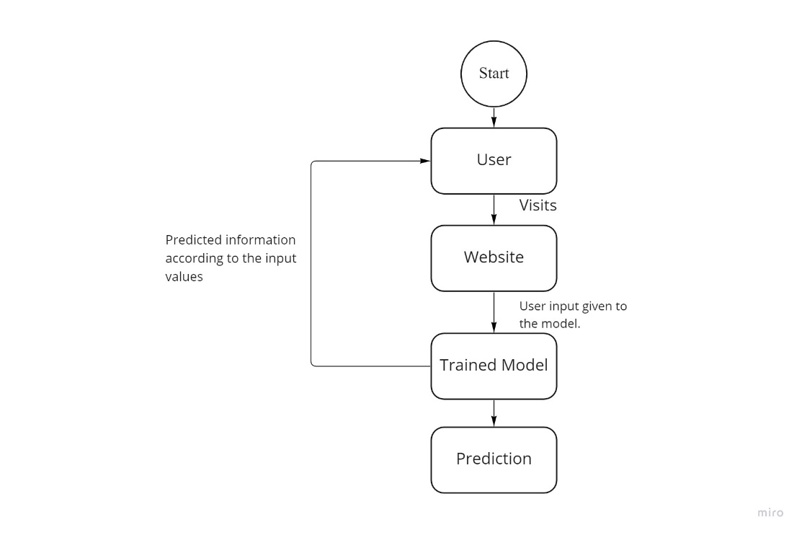

Fig 1

This is our proposed work. In the Fig1 user want to load the webpage. In that user want to upload the image. After uploading the image our proposed system will predict weather any disease is occurred or not. If disease occurred means it will propose the suitable fertilizers.

**SAMPLE INPUT**

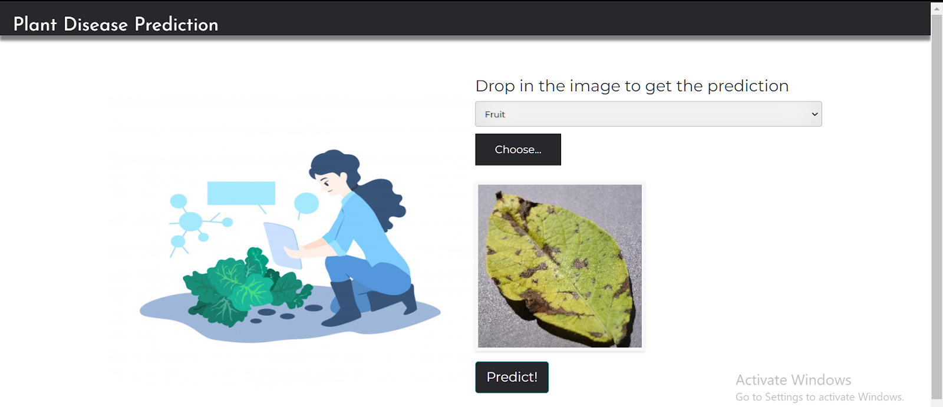

**Fig 2**

In fig 2 the user can upload their leaf to identify the disease occurred. After clicking the predict button it will show the type of disease occurred.

**SAMPLE OUTPUT**

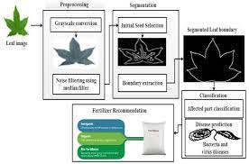

**RESULT**

This system finds the plant disease quickly with the help of deep learning algorithms. Then the image of the plant uploaded will be scanned with the help of convolution neural networks (CNN). The CNN algorithm will recognize the image and then the Deep learning is used to detect the disease and recommends the fertilizer to be used. These process can be done in a faster rate so that the disease can be cured at the starting stage.

**CONCLUSION**

With the algorithms used and the dataset provided the systems makes the best attempt to find the disease of the input leaf image and the fertilizer that can be used to treat it. The accuracy of the system stands high with the ability of detecting the disease. The time taken for computing the disease in the infected leaf is reduced in this system and the memory consumption is also manageable. As the trained dataset grows the efficiency of the system increases which in turn increases the accuracy in finding the disease. Thus the system stands for the betterment of farmer’s welfare thereby increasing the production and the economy of the country. This system can be further enhanced by changing different algorithmic pair to find the disease in a more accurate way.

**FUTURE SCOPE**

This further research is implementing the proposed algorithm with the existing public datasets. Also, various segmentation algorithms can be implemented to improve accuracy. The proposed algorithm can be modified further to identify the disease that affects the various plant organs such as stems and fruits.

**REFERENCES**

[1] Reyes Angie .K, Juan C. Caicedo, and Jorge E. Camargo, "Fine-tuning Deep Convolutional Networks for Plant Recognition", In CLEF (Working Notes), 2015.

[2] Hamrouni .L, Aiadi .O, Khaldi .B and Kherfi .M.L, "Plants Species Identification using Computer Vision Techniques", Revue des Bioressources 7, no. 1, 2018.

[3] Dimitrovski, Ivica, GjorgjiMadjarov, DragiKocev, and PetreLameski, "Maestra at LifeCLEF 2014 Plant Task: Plant Identification using Visual Data", In CLEF (Working Notes), pp. 705-714, 2014.

[4] Naresh, Y. G., and H. S. Nagendraswamy, "Classification of medicinal plants: an approach using modified LBP with symbolic representation", Neurocomputing 173, pp: 1789-1797, 2016.

[5] Sue Han, CheeSeng Chan, Paul Wilkin, and Paolo Remagnino, "Deep-plant: Plant identification with convolutional neural networks", In Image Processing (ICIP), 2015 IEEE International Conference on, pp. 452-456, IEEE, 2015.

[6] Kaur, Lakhvir, and Vijay Laxmi, "A Review on Plant Leaf Classification and Segmentation", International Journal Of Engineering And Computer Science 5, no. 8, 2016.

[7] Kadir, Abdul, Lukito Edi Nugroho, AdhiSusanto, and Paulus InsapSantosa, "Leaf classification using shape, color, and texture features", arXiv preprint arXiv:1401.4447, 2013.

[8] Lee, Sue Han, CheeSeng Chan, Simon Joseph Mayo, and Paolo Remagnino, "How deep learning extracts and learns leaf features for plant classification", Pattern Recognition 71, pp: 1-13, 2017

[9] Joly, Alexis, HervéGoéau, HervéGlotin, ConcettoSpampinato, Pierre Bonnet, Willem-Pier Vellinga, Julien Champ, Robert Planqué, Simone Palazzo, and Henning Müller, "LifeCLEF 2016: multimedia life species identification challenges", In International Conference of the Cross-Language Evaluation Forum for European Languages, pp. 286- 310, Springer, Cham, 2016.

[10] Zeiler, Matthew D., and Rob Fergus, "Visualizing and understanding convolutional networks", In European conference on computer vision, pp. 818-833. Springer, Cham, 2014.

[11] Satnam Singh and Manjit Singh Bhamrah, "Leaf identification using feature extraction and neural network", IOSR Journal of Electronics and Communication Engineering 5, pp: 134-140, 2015.

[12] Vijayashree .T and Gopal .A, "Authentication of Leaf Image Using Image Processing Technique", ARPN Journal of Engineering and Applied Sciences 10, no. 9, pp: 4287-4291, 2015.

[13] Nguyen, ThiThanhNhan, ThiLan Le Van Tuan Le, Hai Vu, NataponPantuwong, and Yasushi Yagi, "Flower species identification using deep convolutional neural networks", 2015.

[14] Mohanty, Sharada P., David P. Hughes, and Marcel Salathé, "Using deep learning for image-based plant disease detection", Frontiers in plant science 7, pp: 1419, 2016.

[15] Chaulagain, Basanta, Bhuwan Bhatt, BipinKhatiwada, and BishalChaulagain. "Plant Leaf Recognition", 2013.

[16] Pujari, Devashish, Rajesh Yakkundimath, and Abdulmunaf S. Byadgi. "SVM and ANN based classification of plant diseases using feature reduction technique." IJIMAI 3, no. 7 (2016): 6-14.